| American Video Game Company |
| --- |
| CRM Proposal |
| C188 Performance Assessment |
| Michael Brown  10/25/2021  Version 1.0 |

Contents

A. Introduction 3

A.1. Purpose Statement 3

A.2. Overview of the Problem 3

A.3. Goals and Objectives 3

A.4. Prerequisites 3

A.5. Scope 3

A.6. Environment 3

B. Requirements 4

B.1. Business Requirements 4

B.2. User Requirements 4

B.3. Functional Requirements 4

B.4. NonFunctional Requirements 4

C. Software Development Methodology 5

C.1. Advantages of the waterfall method 5

C.2. Disadvantages of the waterfall method 5

C.3. Advantages of {a different method} 5

C.4. Disadvantages of {a different method} 5

C.5. Best suited 5

D. Design 6

D.1. Storyboard or Flowchart (Change title to fit needs) 6

D.2. UML Diagram (Change title to fit needs) 7

D.3. GUI (Change title to fit needs) 8

E. Testing 9

E.1. Testing Type (change name to fit your needs) 9

E.1.1. Test Name 1 9

E.1.2. Test Name 2 9

E.1.3. Test Name 3 10

F. Sources 12

# Introduction

American Video Game Compan*y* is proposing for a project in finding a replacement to their internal CRM system to allow for better relationship management of several disconnected manual and automated processes with businesses and leads. In this document I will be providing sections that break down the company's needs, goals and objectives, and offering of a solution for a customizable off-the-shelf system. This document explains the proposed CRM system that fits within the scope of American Video Game Company’s goals, objectives, and requirements in contact relationship management.

# A.1. Purpose Statement

This document encapsulates my suggested offering for an customizable off the shelf CRM system that will lie adjacent to American Video Game Company’s requirements and objectives.

# A.2. Overview of THE PROBLEM

As explained in the CRM Requirements document, American Video Game Company sales is growing at a fast pace and is projected to outgrow its existing systems for managing all aspects of CRM. This newly proposed new system will need to be efficiently capable in managing client contacts and contacts communication, execute sales tracking, manage reporting, and effectively handle reporting.

# A.3. Goals and Objectives

American Video Game Company would like to consolidate all of their contacts and business information into a seamless environment within the proposed CRM system. Activities and interaction tracking with the contacts has been stated as key technical objectives. Many of the company’s users, both internal and remote, will be interacting with the newly proposed CRM system so there will need to be a set of roles and permission based settings for these users. Security is an important factor as well, as contact data will be saved within the databases, so the security of the CRM system will need to be robust. Importantly, the system will need to be scalable and customizable in addition to new enhanced features as needed by the American Video Game Company. The company has stated that the system can be a customizable off-the-shelf system, but it will need to have a means of enabling features for 3rd party contractors to access, and also tools for managing activities and track sales. Additionally, since the system will need to have robust security aligned with industry standards, it will also need to integrate with other systems to allow for intentional sharing of data.

# A.4. Prerequisites

The proposed CRM system, Salesforce, has technical requirements that will need to be met before any usage to maintain a lightning experience. Below are a list of prerequisites that will need to be satisfied before implementing this CRM system.

| Number | Prerequisite | Description | Completion Date |
| --- | --- | --- | --- |
| 1 | Browser | Install machines with latest versions Google Chrome, Mozilla Firefox, Microsoft Edge, or Apple Safari | 10/15/2021 |
| 2 | Networking | Insure network speeds are for downloads are 3 Mbps or greater | 10/19/2021 |
| 3 | Hardware | Machines will be required to have at least 8 GB of RAM | 10/25/2021 |

# A.5. Scope

The proposed system will cover transferring previous data records into the proposed CRM system including emails, contact communication records, previous sales reporting, contact information, previous report tickets, accounts, contact and lead information and activities. The proposed CRM system will also manage contacts, track sales activity, marketing data, and social insights enabling accurate marketing to the most interested customers. Also within the scope, the proposed CRM system will be cloud-based with mobile apps available for the justifiable purpose of being able to stay connected with and up-to-date with sales, reporting, contact communication and more. With mobile and cloud-based system productivity, in-house or remote, will be effective in collaboration, mobilization, and revenue growth through its organizing structure and agile tools that are scalable as the company grows.

The proposed system does not provide machine learning help desk support, spreadsheet automation, or automated version control management. Also the proposed system does not provide the browser, hardware, or networking infrastructure needed to operate.

# A.6. Environment

The proposed system must be compatible with the following desktop browsers in use within the company: latest Mozilla Firefox, Google Chrome and/or Chromium, Internet Explorer v. 9 and above, and Safari 6.0 and above.

Since Salesforce CRM is a cloud-based and mobile system, the following mobile environments are supported to use the CRM system mobilily: Android v4.0 and above via Salesforce App from the Google Play Store or Google Chrome browser, iPadOS and/or iOS v7.0 and above via Apple Safari browser, Google Chrome browser, and Mozilla Firefox browser.

Based on technical requirements, Salesforce CRM perfectly adheres to the needed requirements as their app and web based platform is supported by industry standards in desktop and mobile environments. Because of this, Salesforce is a popular choice within the industry due to their resource-efficient cross platform experience. Notable companies such as Macy’s, T-Mobile, Spotify, and American Express find Salesforce CRM a reliable tool for its features and capabilities.

# Requirements

Two thousand users will access the system simultaneously. Commonly, 500 users may concurrently be using the system during peak times. This traffic will change moderately over time, so a scalable approach to meet the needs of a growing user base is essential. The proposed CRM system must also meet performance standards.

Salesforce CRM will produce a new solution to allow for scalability and give the American Video Game Company the subsequent capabilities:

* Manage Reporting
* Opportunity Management
* Managing contracts
* Contact Management
* Ticketing

These capabilities will be in accordance with the following specified requirements. To meet these requirements, we will build a custom off-the-shelf Salesforce CRM experience that meets each of the conditions specified to meet American Video Game Company's defined requirements to keep up with growth.

# Business Requirements

The proposed system will be required to satisfy the business requirement of contact management by organizing businesses within a particular higher entity group which the system will check for duplicates upon submission. Apart from that, individual contacts will be able to be transferred between businesses or roles. Salesforce CRM provides this within a contact dashboard with editing tools, contact information, and entity groups by verifying the system's editing or creation process with required approval from contact managers. Contact and business information consolidation will be a core functionality to maintain the required organizational structure. Access to data will be available for external contractors as well as permission-based data management for security. Salesforce CRM will store all data within Salesforce U.S. data centers are required unless instructed by approval for exportation.

# User Requirements

Salesforce will allow users to accomplish tasks that include ticketing, contact management, report management and generation, opportunity tracking and management, and contract management. Depending on the user's roles, users will be able to manage contact settings and marketing preferences.

The ticketing system within the proposed Salesforce CRM solution will allow users entry and tracking of every communication and inquiry for contacts. The system will track communication channels on who called, the reason, date/time, and follow-up options, including other relevant details. Salesforces ticketing system provides a vertically integrated communication, entry, and tracking system for contacts.

Backed up by the database for auditing, Salesforce CRM keeps a record of contact parties communicating, the date and time, if a follow-up is issued and any added additional relevant details supplied by either the contact or the representative. All of the previously stated requirements and provided solutions are available in the cloud. They are accessible through required environments, as stated above in the environment section of this document. In Salesforce, contact communication is performed in the chat section on the dashboard where contacts can be contacted through the UI on the right side of the sidebar.

To satisfy the opportunity management requirement presented in the CRM Requirements document, Salesforce will allow users to analyze, track, and manage processes, communication pipelines, and task completion. The new CRM system will show real-time deal analysis across competing products and services along with a win/loss opportunity ratio.

Salesforce supports user-generated and imported predefined reports into the database. The intuitive user interface provides features such as report search, exportation, filtering, and formatting. Users can view and export historical data and dashboards in a high-level summary by using the filtering and search functionality.

Salesforce, the proposed CRM system, will allow users to track the process of contract creation, signing, authorization, and termination of contracts within the dashboard. The CRM will follow terms for every deal and allow for escalated users to approve or authorize contracts.

# Functional Requirements

Salesforce will implement access and version control based on user permissions for all users. Users with administrative role access will be the only accounts available to grant other users' permissions or role-bassed access. The current organizational data structure of users will suffice when migration occurs.

In addition to this, here are some additional high-level functional requirements that the proposed CRM system, Salesforce, will provide as a solution. The use of "soft deletes" can be performed for most users, with administrators having the ability to view users' changes as well as version control and auditing workflows and roll-backs. Whereas, "hard deletes" will be limited to administrators and users with escalated permission access, authorized by an administrator. Because of this, American Video Game Company will be in full control of ownership of data within the cloud database.

The CRM system will deliver pre-verified reports and user-generated reports for all data contained in the databases. Querying reports will allow for the exportation of detailed and comprehensive information. Users will click through the UI, save the data, or save and reuse any applied filters for future reports.

The Salesforce ticketing system will register contact data and communication, supporting the sales team's data analyzing and tracking every communication or inquiry with each contact interaction. The ticket will include form fields for the name of the person calling, the reason for the call, date and time stamps, follow-up, and company name, role, forecast, recent activity, and additional relevant information fields. Each ticket should have a unique ticket number. The CRM database will support all information needed for this workflow to happen. An audit trail of all workflows and database changes can be performed and maintained by the administrators or users with elevated permissions to manage the ticket.

With managing contracts, Salesforce will have the ability to find duplicate existing company names and contacts within a contract form, recommend merging similar names with current records, and be categorized by type or tagged accordingly. With this process, the contract data will be 'clean' and organized in logical hierarchies, allowing the sales team to find contracts and users to easily operative within. All partially completed forms will be flagged for review by an administrator so the entries will be as comprehensive as appropriately possible. During transactions, follow-up, orders, emails, and calls, users may tag requests to a company, contract, or create a new contact or company and tag it to an existing call entry activity.

With opportunity management, Salesforce will give the designated American Video Game Company department the ability to track, process, manage pipelines and analyze competitive products and services. It will implement workflow processes for all functions related to sales, and it will create and follow channels. The CRM will allow sales team members to perform competitive analyses such as win/loss, competitive product, and discount approval analyses. By allowing the sales team to follow the sales process, Salesforce will provide guidance at every stage.

In contact management, the proposed CRM system contacts will have standard fields such as first and last name, account name, job title, email address, phone number, fax, and address. Additional contact fields can be added or removed by the administrator or users with proper permissions. Salesforce has the ability to find duplicate existing contacts within the system during the creation of new contacts and suggests merging fields entered. For quicker entry, each contract form field will have a recommended type and format, verified by an administrator or escalated user with permissions against the recommended type or tag when creating or editing business contracts or individual contracts.

# NonFunctional Requirements

The new CRM tool should be an upgrade from the one previously used by American video game companies. Therefore, performances are expected to be superior to our current CRM tool. The new tool interface should be user-friendly in most aspects of its use. The tool also needs to be easily modifiable to our evolving needs. It should be secure and in accordance with U.S regulations and best practices.

Consequently, Salesforce is industry-leading in its intuitive design that is each to learn and use. Salesforce uses Oracle servers, therefore the ability to scale up adding more contacts and/or users is not only expected but adaptably ready. Many companies within the video game industry and in other industries, choose Salesforce because of how customizable the CRM system is to fit the companies needs. In this case, as stated in the above sections, Salesforce has tools that can be customized to fit American Video Game Company’s needs. Lastly, Salesforce maintains a comprehensive set of compliance certifications and attestations to validate the American Video Game Company's value of trust. Certifications such as the following: U.S. Department of Defense Cloud computing security requirements, FedRAMP High’s U.S. government program providing a standard approach to security, authorization, and monitoring.

# SOFTWARE DEVELOPMENT METHODOLOGY

The American Video Game Company has chosen the waterfall development method. Below, I will be going through explaining the pros and cons of that methodology. Also, I will be introducing an alternative development methodology and its advantages and disadvantages as it pertains to this project.

# Advantages of the waterfall method

The waterfall development method will allow for departmentalization and more control over the development cycle. While using a set schedule with deadlines, each state of development will have a start and finish timeline with a proceeding and succeeding task along the cycle. By doing this, the products will proceed through the development cycle phases one by one without confusion or any development falling through the cracks of the process.

# disAdvantages of the waterfall method

The disadvantages of the waterfall method are that there won’t be a working software prototype until late during the development life cycle. Because of this, there is a high risk of not meeting deadlines and scheduled deliverables. There’s also the factor of uncertainty in certain features not being appropriately implemented due to rushed development trying to meet deadlines. Also, for maintenance purposes, the waterfall methodology is a poor model for long and ongoing projects. Any changes needed to the CRM platform will start back at the development process, which would take some time. Lastly, testing only occurs after the completion of the development cycle. Any changes needed during the project would require restarting the process and prolonging the final release.

# Advantages of Agile Method

Going with the Agile development method would open up the development cycle to be more flexible in implementing the Salesforce CRM platform. Because the American Video Game Company requires a customizable CRM system, making changes throughout the project would be beneficial. Not only would this allow for more opportunities to reprioritize and reorganize tasks, but it would also allow for more improved team collaboration. Developers would be able to collaborate with testers and even the sales team when completely scheduled deliverables. Lastly, because of enhanced team collaboration, an Agile development method would provide transparency and a more efficient release cadence. Team collaboration would allow for features and changes to be delivered more quickly due to tasks not being blocked by previous tasks step-by-step. All assignments will be viewable by each team, thus making greater transparency with the team and the client, resulting in more trust, openness, and communication for all parties.

# disAdvantages of {A DIFFERENT method}

Though the Agile method has its advantages, it also has some disadvantages. For the agile methodology to work, the project team needs to be mature in their approach to developing the project, as the project can very quickly deviate from what the project intended to accomplish if too many changes are made. The project team may lose themselves in the details and lose sight of the original goal of the project. Another disadvantage of the agile methodology is that projects may lag too behind compared to their initial milestones. The project's budget and resources may be depleted very fast if too many changes are allowed to occur in the project.

# best SUITED

The waterfall methodology is best suited to lead this project successfully. From understanding the requirements and the goals and objectives of this project, the American Video Game Company isn’t looking to change its entire data structure, because of this, using a more time structured methodology like the waterfall method would adhere to an organized and timely deliverable transition to the new Salesforce CRM system. The change would be straightforward, and because Salesforce is an off-the-shelve yet customizable service, the focus should be in the later stages of the development cycle in testing and maintaining. The waterfall development methodology is best suited for this project because of its structured step-by-step process that may take more time and have less collaboration among departments, and it will provide a safe and secure transition with the data being transferred over to the new Salesforce CRM system.

# Design

The CRM tool interface mockup created by Figma

* Dashboard page example: 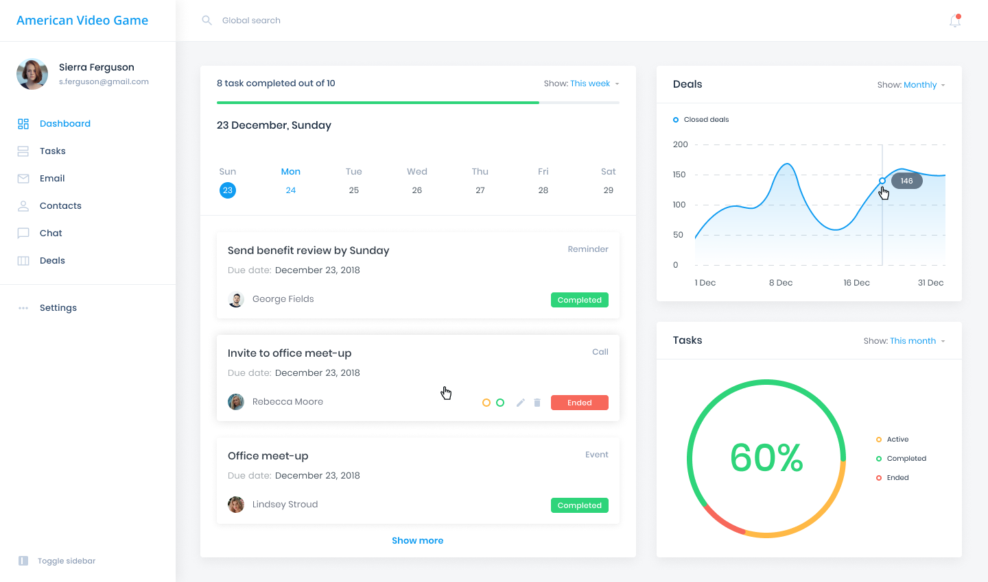

The Dashboard page will provide an overview of the user’s tasks, deals, meetings, possible follow-ups, and calendar information. As explained in the environment section, since this is a cloud-first CRM system, this dashboard can be accessed on multiple devices. Users can filter through Tasks and Deals based on the current month, current week, or current year all of which come from the secure database.

* Contact List section example: 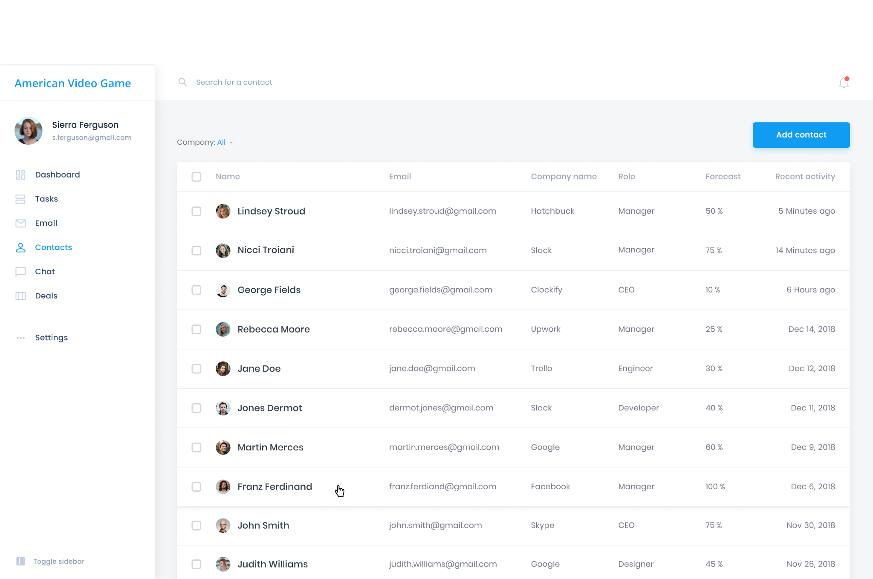

Here you will be able to see how the CRM system tool will be able to provide a list of contacts already entered into the system. Also, users will be able to search for contacts, select a contact, and add a new contact from the “Add Contact” button on the top right corner.

* Contact chat layout mockup: 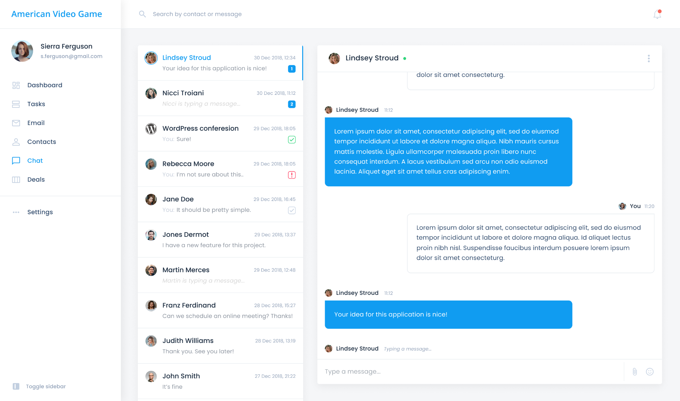

As a requirement, users will need to communicate with contacts efficiently. Within the new CRM system, users will be able to chat with numerous contacts right from the contacts list or sidebar. Features such as being able to send attachments and emojis are available as well as typing indicators and reading receipts. Also, messages can be sent an urgent status for actionable responses needed immediately.

# UML Diagram (Change title to fit needs)

The UML diagram below explains the relational database structure between cases, contacts, and the accounts that are associated with them. Indicating the security standard of not using sensitive data in the CRM tool database.

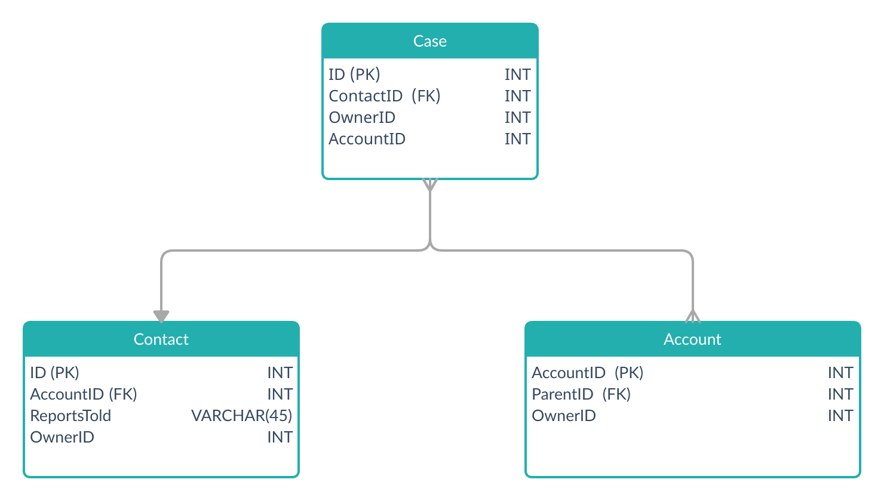

# Testing

Here I will explain three different functionality tests that will be given to the Testing team. The three tests will adhere to the requirements presented by The American Video Game company. Providing a pass in all three of these tests will confirm the core functionality of the new Salesforce CRM system.

# user testing

We will provide 3 tests to ensure the success in the integration of the CRM tool. We chose the following items to test as we see them aligning with the general requirements explained in the CRM Requirements document:

* Sign-in to the Salesforce CRM tool via mobile device
* New contact creation
* Add a contact to a case

# Sign into Salesforce crm tool on mobile device

| Requirements include the following:   * a mobile device that is supported as explained in the Environment section of this document * Wifi or Data connection to connect to the server environment * Google Play Store or Apple App Store to download Salesforce CRM app |
| --- |
| Preconditions: Conditions that must be present before test case can successfully run  Salesforce mobile app must be installed to tap on the Salesforce icon from the Google Play Store or Apple App Store |
| Steps: The steps tester must execute to test the feature.   1. Start the app by tapping the Salesforce icon on your home screen. You see the login page. 2. Enter your username and password. 3. tap Gear Icon. 4. To add the new environment, tap + . 5. Enter the web address for the environment. And enter a label, like My login page or Sandbox, so you can easily identify the environment. |
| Expected results: Expected results and any side effects such as updating a database, writing to a file, etc.  Expect to see environment with your assigned cases and contacts on your dashboard once logged into environment |
| Pass/Fail: Mark whether the test case passed or failed. The results can be compiled and used to determine if the application is ready for delivery/release.  Pass. |

# Creating new contact

| Requirement to be tested  Creating a new contact and confirming that contact information has been submitted properly. |
| --- |
| Preconditions: Conditions that must be present before test case can successfully run  Requirements to test are the following:   * An active account with the role permissions to manually add a contact * A supported device as explained in the environment section * Wifi or Data connection with a secure VPN to the database environment |
| Steps: The steps the tester must execute to test the feature.   1. Gather information about the contact 2. Log into the CRM tool and navigate to “Add new contact” section 3. Create new test contact 4. Submit new contact 5. Wait for new contact to be verified and approved by role administrator 6. Confirm new contact was successfully created by searching through contact list of all contacts in the CRM tool database |
| Expected results: Expected results and any side effects such as updating a database, writing to a file, etc.  The new contact information will be presented and retrieved in the contact sections of the CRM tool. Information of the contact will be accessible from all devices connected to the CRM database tool. All information submitted by the tester must be present in the search list of contacts. |
| Pass/Fail: Mark whether the test case passed or failed. The results can be compiled and used to determine if the application is ready for delivery/release.  Pass. |

# Add contact to a case

| Requirement to be tested  Add a contact to a case and confirm that all contact information is added to the case as well as the contact is shown added within the contact case list. |
| --- |
| Preconditions: Conditions that must be present before test case can successfully run  Contacts needing to be added to a case can be added by the primary case contact on the case (usually the person who opened the case) or by users in the organization who have been designated as a Help & Training administrators for the organization. The case contact (user creating the case) can't add themselves as a contact on a case.  The contact must already be within the CRM system list to add to a case. |
| Steps: The steps the tester must execute to test the feature.   1. Access your support case in Salesforce Help. 2. Click on the Details tab. 3. In the Case Contacts section, click the pencil icon. 4. Search for a contact to add, then click “Add” 5. Click Save. |
| Expected results: Expected results and any side effects such as updating a database, writing to a file, etc.  The contact and all of the contact information will be added to the case section that the contact has been added. |
| Pass/Fail: Mark whether the test case passed or failed. The results can be compiled and used to determine if the application is ready for delivery/release.  Pass. |

# Sources

* “*Case Collaboration in Salesforce Help” Salesforce*, https://help.salesforce.com/s/articleView?id=000334556&type=1
* “*Agile vs Waterfall Methodology | Difference between Agile and Waterfall | What to choose?*”, https://youtu.be/5RocT_OdQcA
* “*Technical Requirements for Lightning Experience*”, https://help.salesforce.com/s/articleView?id=sf.technical_requirements.htm&type=5
* “*Compliance engineered for the Cloud*”, https://compliance.salesforce.com/en